**Course 4-Display custom animation**

****Learning goals:****

This lesson learns to display custom animation on a micro:bit dot matrix by Python programming. For example: from smile to sadness and then to anger.

**Code:**

from microbit import *

while True:

face1 = Image("00000:09090:00000:90009:09990")

face2 = Image("00000:09090:00000:99999:00000")

face3 = Image("00000:09090:00000:09990:90009")

face4 = Image("90009:99099:00000:09990:90009")

face5 = Image("00000:00000:00000:00000:00000")

all_faces = [face1, face2, face3, face4, face5, ]

display.show(all_faces, delay=200)

**Programming and downloading：**

1. You should open the Mu software, and enter the code in the edit window, , as shown in Figure 4-1.

**Note! All English and symbols should be entered in English, and the last line must be a space.**

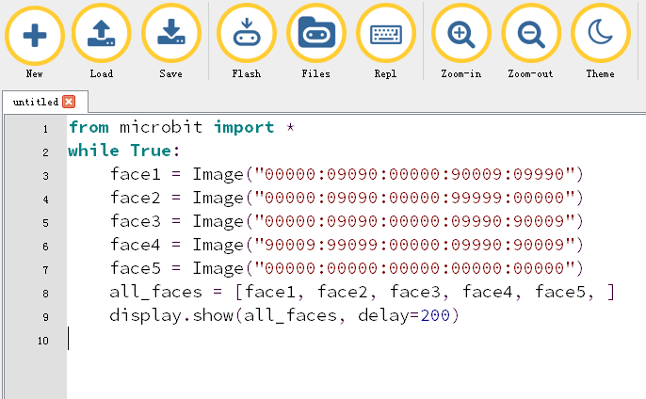

Figure 4-1

2.As shown in Figure 4-2, you need to click the Check button to check if our code has an error. If a line appears with a cursor or an underscore, the program indicating this line is wrong.

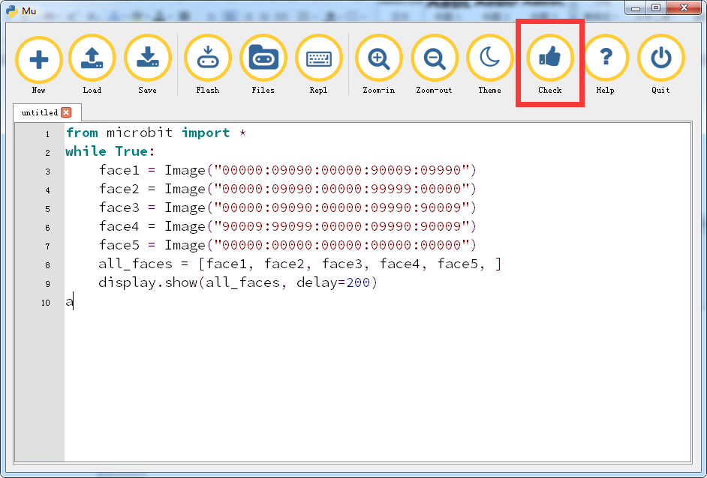

Figure 4-2

3.You need to connect the micro data cable to micro:bit and the computer, then click the Flash button to download the program to micro:bit as shown in Figure 4-3.

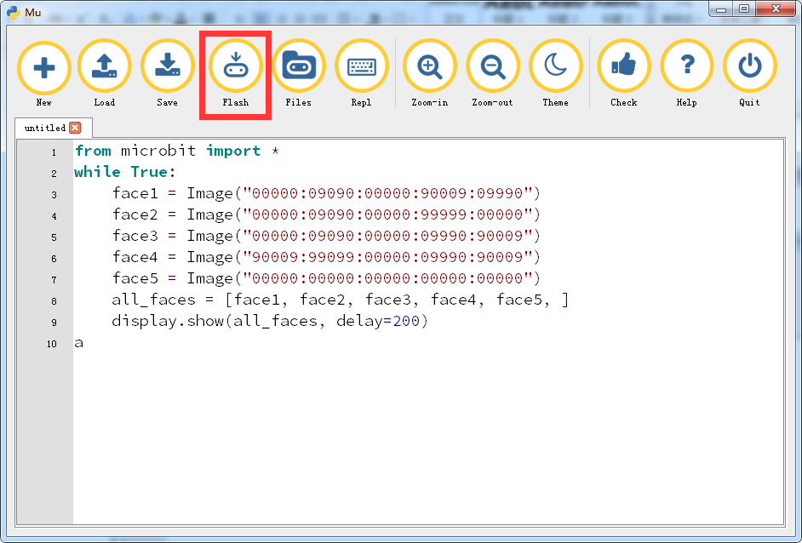

Figure 4-3

4. After the download is successful, you can observe the animation of the expression change on the micro:bit dot matrix, as shown in Figure 4-4 to Figure 4-7.

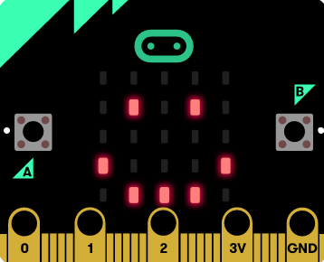 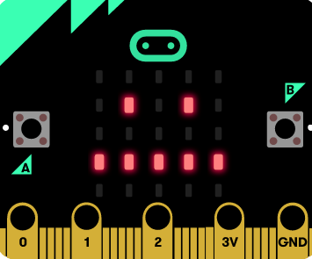

Figure 4-4 Figure 4-5

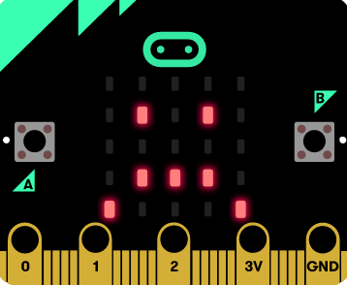 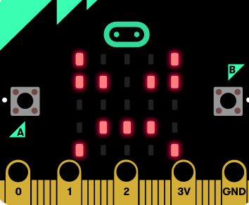

Figure 4-6 Figure 4-7